Ikhlas Attarwala / MSAI 330 – HCI

Section: MSAI / 01/13/19

P 1.2: Project Proposal

1. Problem & Motivation

This problem would tackle the lax and leisure career drive many of us have despite wanting to do more or be better than who we are today. The motivation for this problem is that many of us have a goal or direction we want to follow and achieve, but we have so much else going on in our day to day lives that we can’t always focus on the next step, and instead spend too much time worrying about today’s deadlines and requirements. Sometimes procrastination steals time away from us, and sometimes there are individuals that want to do great things but may have psychological disorders such as avoidant behaviors that hinder them from accomplishing tasks when it’s expected of them, consequently limiting their reach. This project aims to remind people of their interests and help them acquire resources they don’t actively search for on their own. This can be done by reminding them during times of procrastination or providing additional resources based on search history. As mentioned from this class, auto-engaging programs can be better than those you have to interact with to give you the right push in promoting behavior change. It would take time, but the world would see more contribution with reminders not for snapchat or facebook or twitter alerts, but for those goals you want to pursue. It’s a complicated task because it’s not experimented on yet, nor are there initiatives I can find online of similar apps/programs, and matching human interest by say, instance-based learning, can take a while for expert programmers get right.

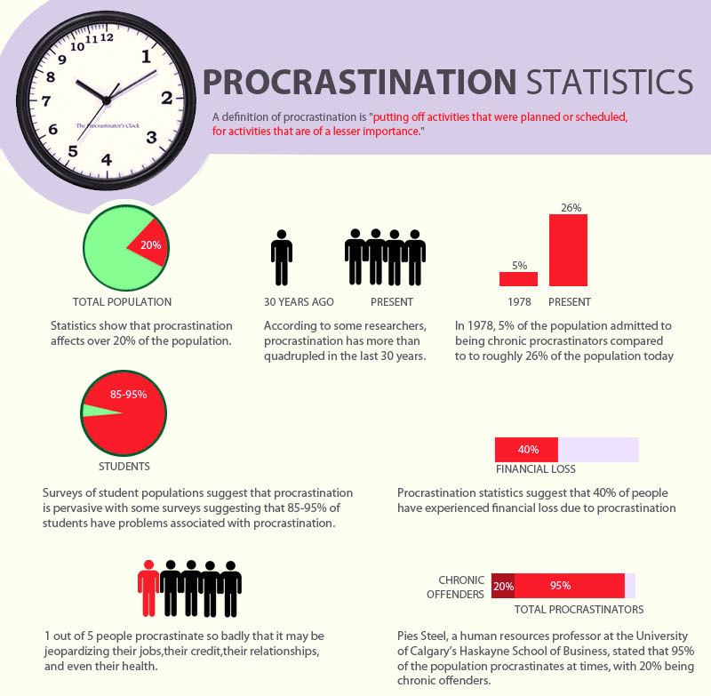

1. Analysis

As mentioned above, issues like an individual’s tendency to procrastinate and work at the last minute (avoidant behaviors) may not be easily treatable; sometimes these tendencies may have psychological proclivity and not be as treatable as telling a person to “get their act together”. Reminders for getting our work done and seeing what else we can do with our time instead of playing video games or watching TV shows can slowly start to become more habitual and lead to better productivity. If the project group wasn’t able to record how long a person commits to a procrastinated activity, they may be able to acquire information from game engines such as Steam that already record how much time an individual spends on a specific video game. ‘Expecting’ this time loss of activity (procrastination or just work in general) at its start can initiate the program to suggest a user a different activity, reminding them of what obligations they have to commit to. The most I’ve seen of the current world addressing better productivity are **parental controls**, that you have to manually set up. I think the last time I saw a program stop itself was Netflix (years ago) when **it suggested I do another activity** because I had spent 3 hours on one TV show. I believe that feature has since been removed. **This 3rd-party program is required because**, well let’s be real for a moment, no entertainment system out there wants to limit you to use it itself less. Netflix/Steam/Facebook/all of them feed on your procrastination. Productivity has monumental effects on our future well-being.

1. Sources used:
   1. <https://medium.com/darius-foroux/how-to-beat-procrastination-backed-by-science-969115e4e389>
   2. <https://www.psychologytoday.com/us/blog/in-practice/201303/why-avoidance-coping-is-the-most-important-factor-in-anxiety>
   3. <https://books.google.com/books?id=kpGNAgAAQBAJ&pg=PA43&lpg=PA43&dq=kanus+1993+self-development+personal+maintenance&source=bl&ots=V3odtr0m-c&sig=2Acl7Z9yTZA_yR9vVGh6lfaPMeQ&hl=en&sa=X&ved=2ahUKEwjTq9KkyuzfAhUJ54MKHYdWB9oQ6AEwDXoECAkQAQ#v=onepage&q=kanus%201993%20self-development%20personal%20maintenance&f=false>